Smart Technology Mentors Program
Informational Meeting for Juniors

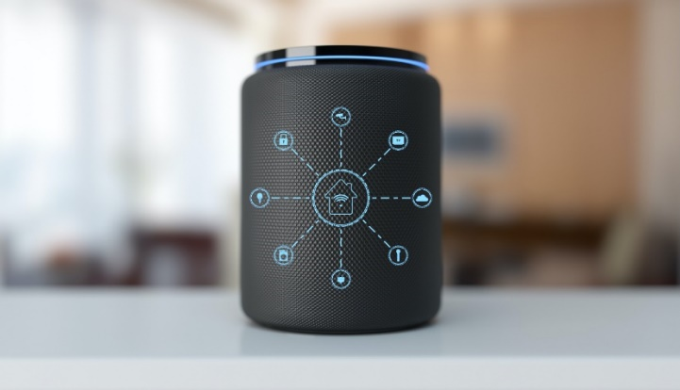

When: [Insert date & time: 0:00 to 0:00]

Where: [Insert school location]

What: A statewide pilot program providing high school seniors opportunities to:

- Receive training to assist older consumers and people with disabilities to live more independently through the
use of smart home devices and services
- Provide the assistance On Your Schedule and Get Paid for each home visit
- Earn recognition as one of Illinois’ first certified
Smart Technology Mentors and be listed on the
Smart Self Reliance Clearinghouse: www.smartselfreliance.org

Join Us to Learn More!

